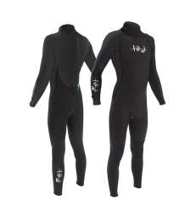
Wetsuit Size Request Form

For Ghyll Scrambling we provide all specialist safety equipment, including full length winter thickness wetsuits and neoprene socks (to go inside your shoes) to keep you snug. You’ll need a pair of good trainers or boots (no water shoes or flimsy footwear) plus a pair of leggings or joggers for over the top (no shorts).

Your comfort is important to us, so please provide us with the following information so that we can pack you a selection of wetsuits for each person to make sure they get one that fits perfectly.

Men – T-shirt Size (e.g. Large), Weight, Height and Shoe Size for the wetsuit socks

Women – Dress Size (e.g. Size 10), Weight, Height and Shoe Size for the wetsuit socks

Children – Clothes size (e.g. child’s 10-11yrs), Height, Age and Shoe Size for the wetsuit socks. Also let us know if they are particularly big or small for their age.

Please email your form back to: info@pathtoadventure.co.uk asap or alternatively, send us these details via email.

Participant Name | T-Shirt/Clothes Size | Height | Weight | Age (Children only) | Sock Size

